PBG KIWANIS SCHOLARSHIP APPLICATION

ELIGIBILITY:
Senior attending Dwyer or PBG high school that plans on attending a college in FL.

Deadline:
May 1st

TO APPLY:
Please submit a 1-2 page essay about yourself, your school ambitions, your community activities, and your cumulative transcript of your grades with GPA included. Please let us know which school you plan on attending as well as why we should select you.

SEND TO:
Isaac Fox
209 Lone Pine Dr.
Palm Beach Gardens, FL 33410

QUESTIONS:
isaac.fox@nm.com
561-284-2543
www.pbgkiwanis.com

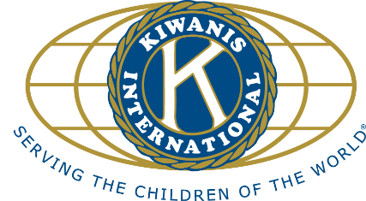

KIWANIS

WHAT IT IS:
A worldwide service organization for individuals desiring personal involvement in the leadership and improvement of their communities.

WHERE IT IS:
In the U.S., Canada, Mexico, Central and South America, the Caribbean, the Far East, Southwest Pacific, and Europe, all for a total of 90 nations.

WHAT IT DOES:
Performs community service; assists the aging, the needy, and the youth; improves communities; encourages international understanding.

THE NAME:
From the Indian words “Num Keewani,” which means, “Self-Expression.”

THE MOTTO:
“Serving the Children of the World.”

